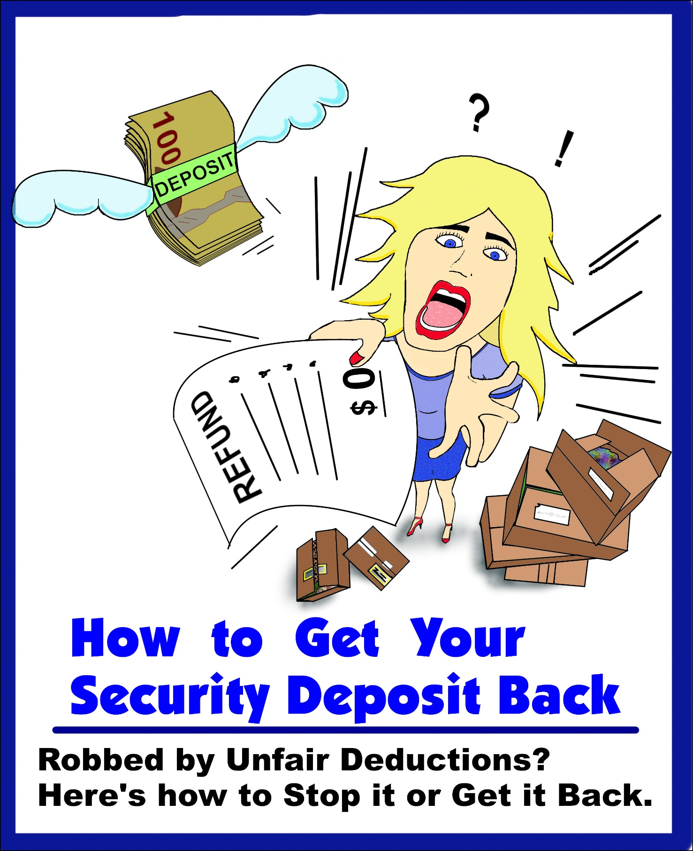

Copyright © 2024 by Certified Property Services Ltd.
All rights reserved.
Printed in Canada.

No part of this publication may be reproduced, stored in a retrieval system, or transmitted in any form or by any means, electronic, mechanical, photocopying, recording, or otherwise without the prior written permission of Certified Property Services Ltd.

How to Get Your Deposit Back provides tenants with information about their rights. This publication is not an exact statement of the law. It is not legal advice.
For an exact statement of the law, you must read:
● The Residential Tenancies Act and regulations
● Minimum Housing and Health Standards by Alberta Health

This book is FREE to Alberta residential tenants, while supplies last.
This publication is not for sale.

Table of Contents
Chapter One: Moving Out
Notices.……………………….………………………….……. Page 1
Filing Your Documents…………..….………………..… Page 5
Chapter Two: Preparation
Handling the Stress.…………………………….….……. Page 7
Pre-Inspection Advice…………………………....……. Page 8
Protect Yourself……………………..……..……….……. Page 10
Chapter Three: Cleaning
How to Clean………….……………….……………..…… Page 12
Chapter Four: Deductions
4 Secrets ……………………….……………………..…….. Page 14
FAQ ……………………….…………………………..…..….. Page 15
Important Message:
Information alone doesn’t get your deposit back.
You have to do stuff . . .
You have to
- Help Yourself (Ch. 1-3)
- Get Help if Needed (Ch.4)
Don’t assume that you will lose your deposit.
Even if you didn’t clean perfectly, broke your lease, or had damages, it’s possible to get most or all of your deposit back.

Chapter One:
Moving Out!
HOW DO I MAKE A NOTICE?
- Write it saying that you are giving One Month Notice.
- State your address.
- State the date of moving. This has to be on the last day of the tenancy month (always the day before the next rent is due).
- Sign it
- Deliver it in person to your Landlord on or before the rent due date (usually the 1st of the Month). Your Landlord may not accept an e-mail or text message notice.

Notices
Almost all tenancies are Monthly or Fixed-Term or a blend of the two.
You Must provide a Written Notice if you want to end a Monthly tenancy!
** For Fixed-Term tenancies, you are supposed to move out on the expiry date of the term or negotiate a renewal. Notice is not required, but you should advise the Landlord that you are moving. **
Life happens, sometimes breaking a lease has to be done –- Job loss, cancer, love, or for any other reason. However, there are ways to guarantee that you get your deposit back!
Periodic Tenancy: A tenancy that automatically renews like a month-to-month tenancy.
Fixed-Term Tenancy: A tenancy for a term that ends on a day specified in the agreement.

sk
Chapter One: Moving Out
CAN I USE MY SECURITY DEPOSIT FOR MY LAST MONTH’S RENT?
No, don’t do that. You must pay your rent on the first of the month.
If you don’t, you can be evicted without a 14-day Notice and have to pay a fee.
Even worse – the Landlord might seize your vehicle!

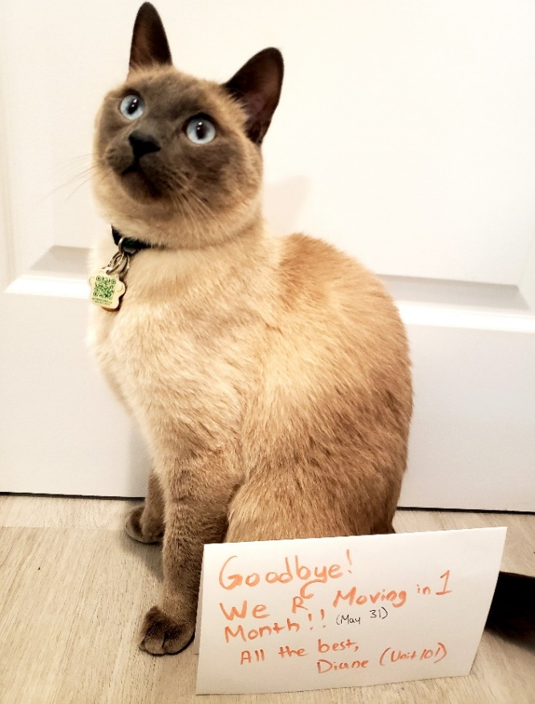
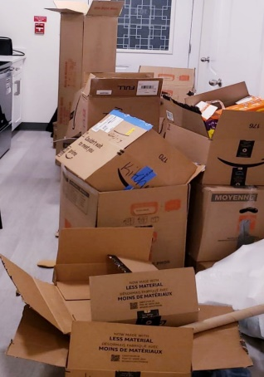
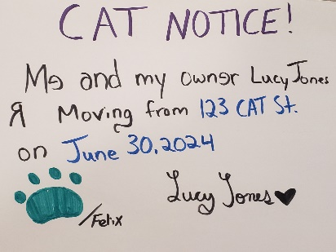
Advance planning helps to leave you time to clean for the inspection. Boxes first.
Giving your Notice in-person on or before the 1st of the Month is the best method!
I GAVE MY NOTICE ONE DAY LATE … IS THAT TOO LATE?
Yes, it’s late.
But ask your Landlord if it’s acceptable and get it in a text message or email. Most times, it’s not a problem but you have to get it in writing.
If it is not accepted by your Landlord, then the Law deems it effective at the end of the next month!

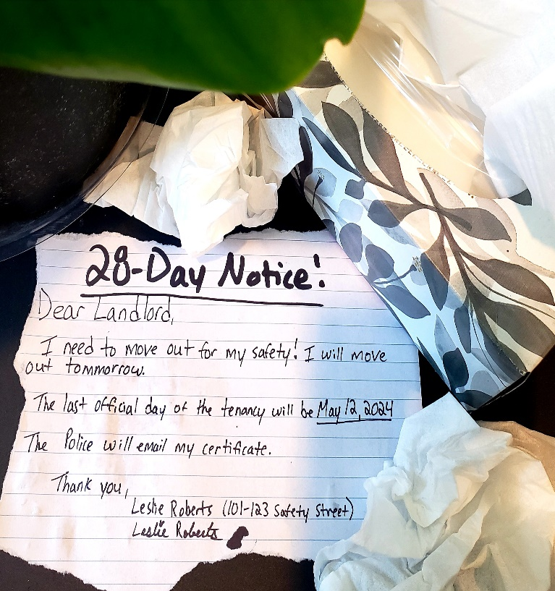
Chapter One: Moving Out
MY BOYFRIEND BEAT ME UP, HOW CAN I MOVE?
If you are in danger, you can get out of your lease in 28 days without fees!
But you will need a certificate. This is a special permission slip that says you can leave your lease early because of the violence.
For more help and information on how to get this certificate, Jennifer can visit:
www.alberta.ca/safer-spaces-certificate
If you are facing danger, you can move out immediately, you do not need to stay the 28-day Notice period!
Ending the Lease for the victim will also end the Lease for everyone else who lives at the residence.

This will do it. This is a proper notice to terminate in an abuse situation subject to a Certificate.
What is Domestic Violence?
Abusive behaviour by one person to another. It can be in the form of screaming insults, controlling s0meone else’s money, sexual assaults, threats with weapons, psychologically abuse, and more.
In an EMERGENCY, you do not need a Certificate to move out!
• Call the Police (911) if you are in danger.
• Call the Family Violence Info Line (310-1818) for information on emergency supports, such as food, shelter and transportation.
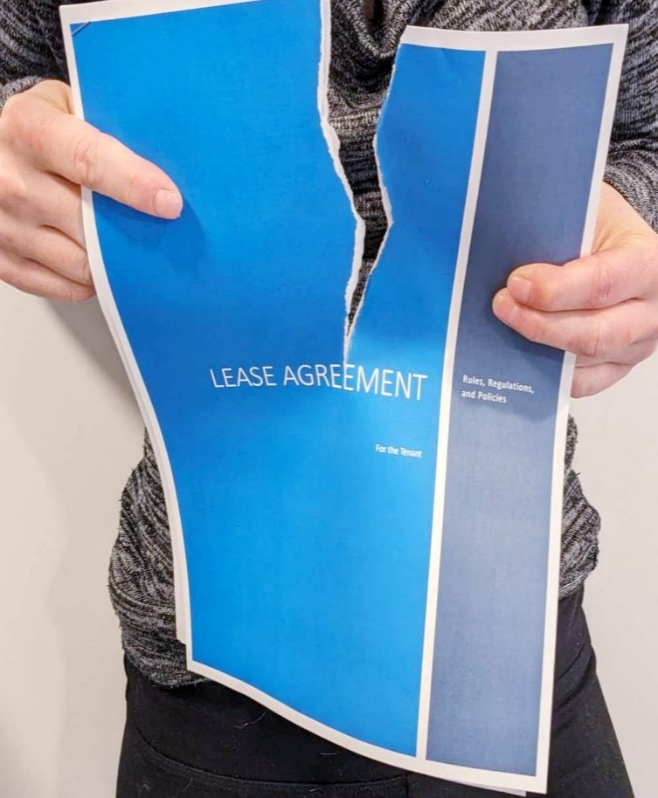
Chapter One: Moving Out
Read your Lease.
Is there something in your Lease that says what happens if you move-out early?
Talk with your Landlord.
You’re much more likely to get out of a Lease without trouble if you’re on good terms with your Landlord. Try talking to them about your situation and see if a mutual agreement can be made.
Find someone to take over your Lease.
Assigning your lease requires requesting written permission to do so! If you don’t get written permission in 14-days then you can assign your lease to or consider subletting to a relative or friend. You receive the rent and continue to pay your Landlord.
Breaking your Lease doesn’t have to mean waving goodbye to your deposit. There are ways to get some or all of it back!
MY MOM IS DYING AND I NEED TO BREAK MY LEASE!
My world is turned upside down. My mom is battling cancer in Ottawa, and now given a bad prognosis. Time is slipping away, and I must be by mother's side during her final moments.

Clean your place when moving out
Even when you are breaking your lease, you should remove everything and clean up!
Call Tenant Aid to get cash back
In most cases, we can sue for your deposit in a Lease-break and get cash back!

Chapter One: Moving Out

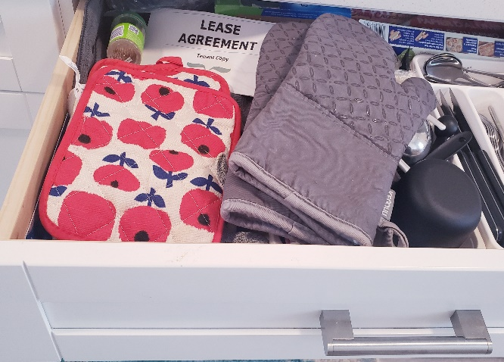
Filing Your Documents

Keep all papers related to your tenancy including:
- Tenancy Agreement
- Move In Report
- Communications
Keep all communication that you have with your Landlord.
File every notice that you get including rent increases, entry notices, and eviction notices.
Print emails and texts and file them in your folder.
These essential files will be important evidence in the event that you have to sue to get cash back from your Landlord.

If you are unsure, Tenant Aid can look at your situation and file for you. And upon being accepted, Tenant Aid guarantees that you will get money back from your Landlord!
Don't put tenancy documents in a drawer! It is best practice to use a folder and an electronic copy of it! it.
- Photos
Take photos of every room, the yard, and every defect upon moving-in and throughout your tenancy. Date-stamp your photos.
Take photos of every repair as well!


Home Sweet Hell: Tenant Sues Her Landlord for His Neglectful Ways
Chapter One: Moving Out
Battling Injustice, One Repair Request at a Time
W
hen Janey moved into her cozy townhouse after graduating from university, she was full of excitement and hope for her new chapter. As she settled in, she discovered a string of problems that weren’t noticed during her move-in inspection.
Always communicate with your Landlord in writing and save a copy.
Only 2 days after moving in, Janey's excitement began to dim as she discovered that her washing machine didn’t work. 3 days after that, she found a leak under her kitchen sink, and to top it all off a bad smell was coming from her downstairs bathroom. Without hesitating, Janey reached out to her landlord, pouring her concerns into emails and texts, hoping for repairs.
But as days turned into weeks, and weeks turned into months, Janey became very frustrated with her Landlord. Even with her many attempts to contact her landlord, the issues remained unfixed. With each ignored message, Janey felt more and more helpless.
Yet, amidst this chaos, Janey remained focused on her goal. She kept records of every text, every email, every unanswered call, and every plea for help. She was prepared with a binder full of evidence and refused to let her landlord get away with this.
Janey knew she needed support in this battle, so she went to a paralegal for help. They worked on her case together and sought justice. The court held her landlord accountable for his failure to address the many repair issues. And Janey was awarded money for the troubles she faced.
Reclaim what's rightfully yours!! Text or Call Tenant Aid now to get cash back from your landlord for those long-overdue repairs.

Chapter Two:
Preparation
Long-distance Moves:
- Make a Moving Plan and Checklist
- Start Packing Early
- Create a Budget
- Purchase Moving Insurance
- Update your Documents with Your New Address
- Make a Plan for your Pets
- Hire Movers or Rent a Truck

Handling the Stress
Moving is stressful! Here are some survival tips:
- Pack Earlier than You Think
- Leave Items that You Use Daily for Last
- Start Small

- Sort and Label your Boxes in a Way that Will Make it Easy to Unpack
- Schedule your Move-Out Inspection as late as possible.
- Decide who will help you move. Do you need to hire movers?
- Get Enough Sleep
- Confirm the Move-In Inspection at your new place.
Paying rent is the best way to cancel an Eviction Notice for Non-payment!

Chapter Two: Preparation
PART B: Pre-Inspection Advice
Most Tenants don’t do this.
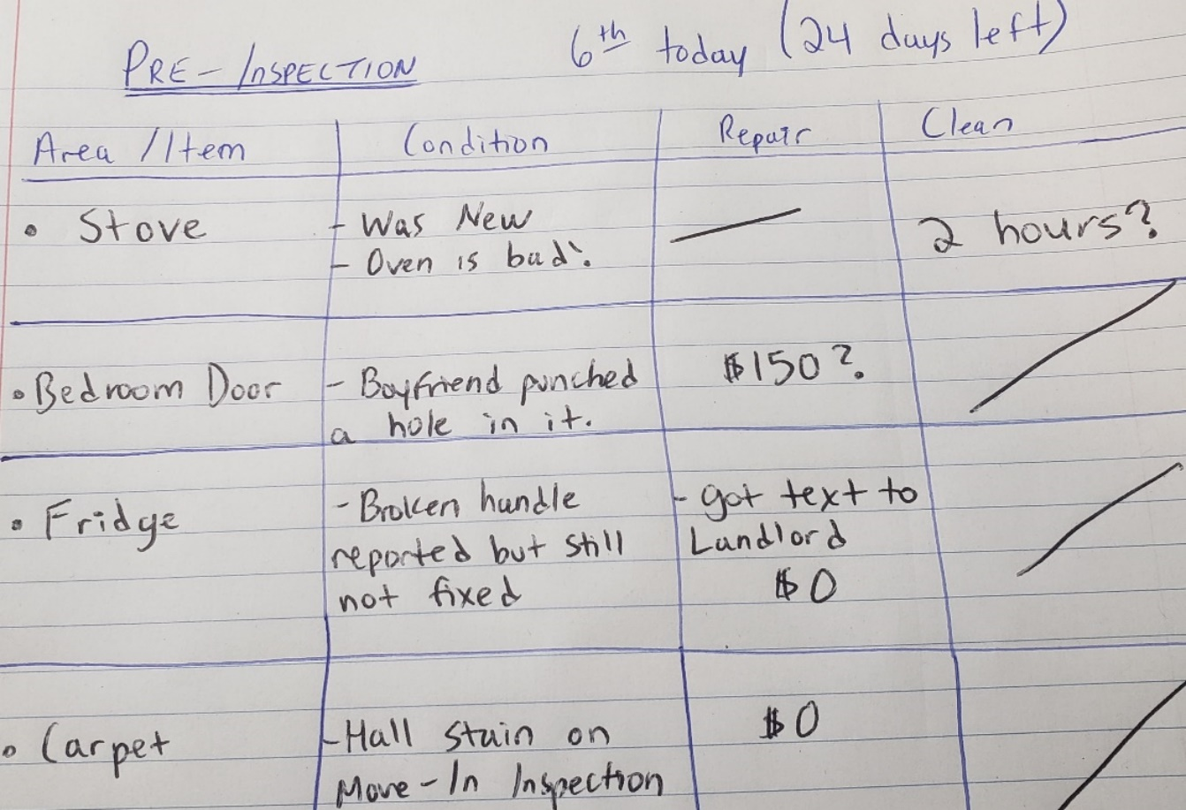
A careful pre-inspection will help you prepare for your move-out inspection.
Without a pre-inspection, you have little chance of cleaning and repairing things to guarantee for a deposit back.

Write your pre-inspection somewhat like this to get an idea what you have to do.
Chapter Two: Preparation
Keep track of all damages and repairs during your tenancy.
Do a decent clean and keep your place in good repair upon moving out -- You are not expected to leave your rental looking like a spotless show-home!!
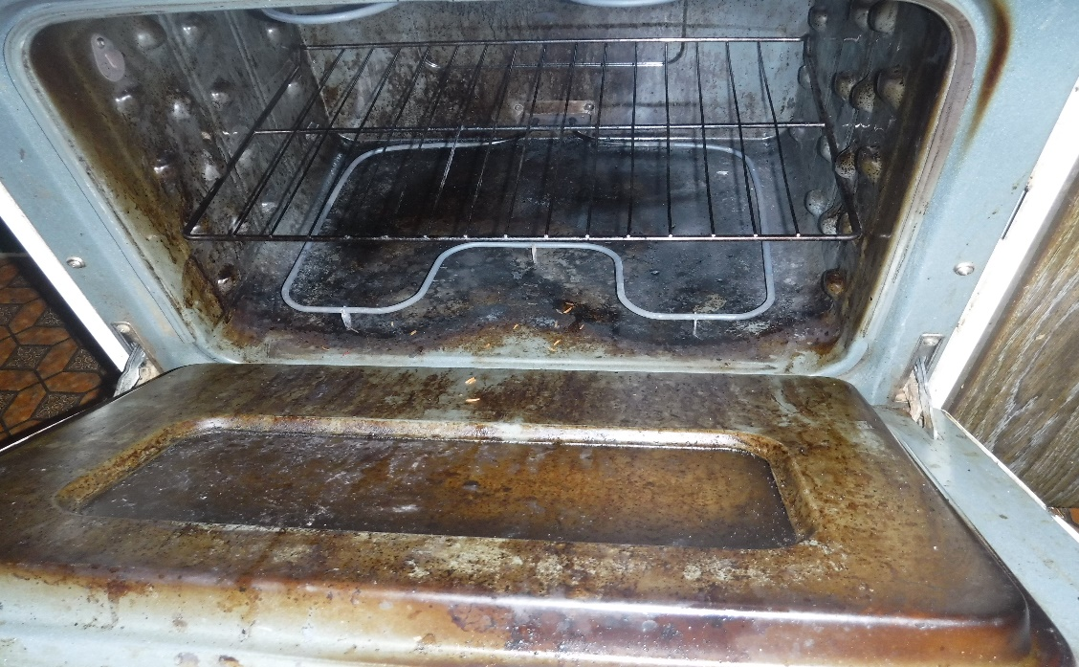
Your Landlord cannot charge you for damages that are from normal use!
If your Landlord does take from your deposit, Tenant Aid can help you get your money back!
Yikes. This will take 2-hours to clean.






- Take photos of every room when you first move in. Be sure to take close-up photos of every defect that you find!
- Take photos of your belongings.
- Do all your communication with your Landlord in writing (emails, text messages).
- Keep a record of all communication and dates relating to repair requests, sewer backups, bug infestations, etc.
- Store communication and all documents relating to your Lease in a safe area.
- Ask for receipts for each payment.
If you have done all of these things and your Landlord still hasn’t given you your deposit back, call TENANT AID @ 587-227-3442 and we Guarantee that you will get your cash back!
HOW TO PROTECT YOURSELF SO YOUR LANDLORD CAN’T KEEP YOUR SECURITY DEPOSIT!
Chapter Two: Preparation
Protect Yourself
Chapter Three:
Cleaning

How to Clean
General Cleaning Responsibilities
Check in your Lease or with your Landlord to see if there’s a Cleaning List!
- Remove all your belongings
- Remove all garbage and debris
- Sweep and wash floors
- Clean, in, out, behind, and under the stove and clean the oven and burners on the stove
- Clean in, out, behind, and under the fridge
- Clean the bathroom thoroughly (tub, floor, sink, vanity, mirror, medicine cabinet, toilet, etc.)

- Dust or wash fans, vents, light fixtures & replace burnt out lightbulbs
- Wash all walls
- Wash all windows
- Dust window blinds
- Wash cupboards inside and outside
- Vacuum and clean the carpets
- Clean yard and garage


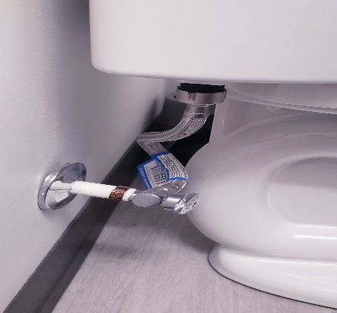
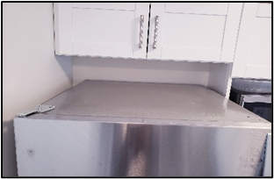
The blinds and Windows
Inside the Dryer
Inside Cabinets
Inside Fan Vents
Behind the Toilet
Top of the Fridge
Baseboards and crevices of the Doors
Windows: Blinds, Screens, and Windowsills
Inside of Cabinets
Top of Door Frame
Bathroom and Kitchen Fans
Cobwebs on Ceilings and Walls
Shelves, Drawers, Inside and Outside of the Fridge
Light Switches
Inside the Dishwasher
Racks, Inside and Outside of the Oven
Top of the Cupboards
Ceiling Fans and Lights
Underneath and around all Appliances (Fridge, Stove, etc.)
Washing Machine gasket
Weeds in Outdoor Spaces
Chapter Three: Cleaning
The blinds and Windows
- Top of the Fridge
- Top of the Cupboards
- Baseboards and Windowsills
- Light Fixtures
- Bathroom Vents
- Behind the Toilet
6 Commonly missed spots:
Behind the Toilet
Top of the Fridge
Chapter Three: Cleaning
3 Rules for Moving Out to Guarantee Money Back from Your Landlord

- Reasonable Cleaning Must be Done.
It’s best to do it yourself along with help, if possible.
Make sure you follow the list of Commonly Missed Spots (Page 13)
Always clean. Even if you are being evicted or are already breaking your lease. Never assume you lost your whole deposit! When you get Tenant Aid to represent you, we guarantee you’ll get your money back if you left the place clean!
- Take Lots of Pictures.
Turn on “date-stamp” on your camera, smart phone, or i-pad.
Take overview photos in every area. -- Every room, every door, the whole kitchen, inside cabinets with the doors open, the yard and garage.
Check your photos to make sure they are sharp and clear. Re-take the photos that are blurry or if they have bad shadows.
- Sign the Move-Out Report ‘all is clean’ or else don’t sign it at all!
Do not sign where you are told to sign. Review the report to make sure that all is marked clean with minimal damages.
The Law requires the move-out report to have 2 statements for you;
(1) I, (Tenant’s name), agree that this report fairly represents the condition of the premises (Signature)
(2) I, (Tenant’s name), disagree that this report fairly represents the condition of the premises for the following reasons: __________________
The Law requires that a copy is given to you.
If you followed the above 3 rules and are not happy with the deductions, that your Landlord made, call Tenant Aid to Guarantee getting money back from your Landlord!
Call Tenant Aid to represent you.

- Normal Wear and Tear is not chargeable
Many Landlords take advantage of Tenants and take money for things that are caused by daily use. Landlords can’t deduct for carpet cleaning because that is normal wear and tear.
Tenant Aid keeps a record of these types of cases and will pick the right ones to defend your case!
- Damages are Subject to Age-Depreciation Costs
If your boyfriend kicked a hole into the bedroom door and it turns out the door was more than 15-years old, then the Landlord cannot charge for this damage because the door was already old to start with!
Tenant Aid has the list of age-depreciation rates that Tenancy Dispute Officers use to limit how much a Landlord can take.
- Cleaning Costs are ALWAYS over-deducted
Landlords overcharge on cleaning rates, Courts limit this to slightly above minimum wage.
A reasonably good clean is good enough!
Photos taken at move-out are GOLD for getting your deposit back. Slight damages do not show well in photos!
Call Tenant Aid to get help with photos.
- No Move-in Report = No Deductions
When your Landlord doesn’t do proper inspection reports, it becomes really hard for your Landlord to take from your deposit!

Chapter Four:Deductions
4 SECRETS your Landlord does Not Want you to Know about Deductions

Chapter Four: Deductions
Frequently Asked Questions
WHAT TIME DO I NEED TO BE MOVED OUT BY ON MY LAST DAY?
You have to be moved out by noon on your last day, unless you and your Landlord have agreed upon another time.
DO I HAVE TO LEAVE MY UNIT SPOTLESS AND PERFECT?
No. You should do a reasonable clean before moving out, but you do not need to break your back making everything spotless.
WHAT IF MY LANDLORD LIES AND SAYS I CAUSED DAMAGE?
Reach out to Tenant Aid for support! If you've followed the guidance in this booklet, we can stand up for you and ensure you receive the cash that you deserve.
CAN MY LANDLORD MAKE ME PROFESSIONALLY CLEAN THE CARPETS?
If the carpet is worn from normal daily usage, your Landlord cannot force professional cleaning. Even if they write it in the Lease, it is not legally enforceable to make you hire a carpet cleaning company for normal-use of the carpet!
Just do a normal vacuum and clean of the carpet, and you will be okay.
HELPING HANDS AND QUESTIONS.
Tenant Aid has lots of advice for you. We can Answer your Questions.
If you followed the advice in this booklet and you get deductions, call Tenant Aid, We Guarantee some cash back from your Landlord!










